Student Name |  | Teacher Name
 Back to School
Students – Each Student who turns in a completed sheet by Thursday, September 1st will receive one entry per completed sheet for a special prize drawing.

Please follow these guidelines when submitting your Box Tops sheets:
Only valid Box Tops should be attached to this sheet. Please, no expired Box Tops.
- Box Tops should be neatly trimmed and the expiration date must be fully visible.
- Tape one Box Top onto each of the apples below. Bonus Box Tops need to be placed in a baggie & stapled to your sheet.
- Go to http://www.granvillek6pto.org/ & click on the 'download' tab to print additional copies of this sheet

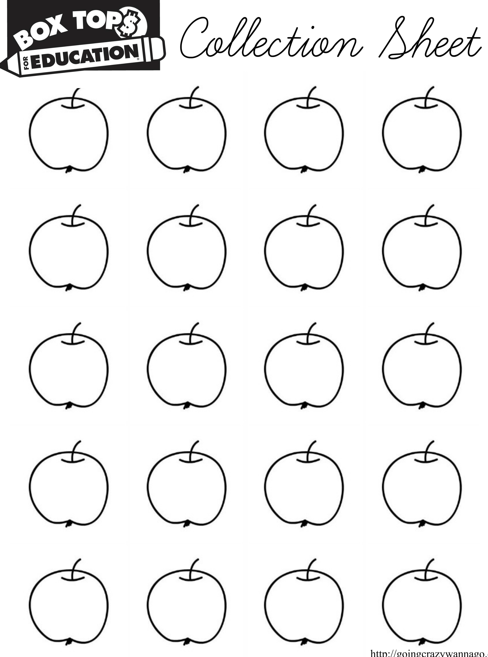

Each sheet that contains 20 Box Tops is worth $2.00 for our School!

